**Product Requirements Document (PRD)**

**Product Name:** WACs-Integrated E-commerce Financing Platform (4Core Project “OYNX”)  
**Partner:** WACS (for loan management)  
**Developed by:** Sapphire Virtual Network Limited  
**Date:** July 2025  
**Prepared by:** Seyi & John – Project Managers

**1. Business Overview**

**1.1. Vision Statement**

To empower Nigerian civil servants with access to a varying range of products and services through a digitally seamless e-commerce platform that enables flexible financing via WACs payroll deductions. ( from mobile devices; Solar Products; payday loans; Insurance; Household appliances; etc )

We are partnering with **Wacs** to help **1.6 million civil servants** across Nigeria buy various assets and pay over time using their salaries.

**1.2. Core Value Proposition**

* Purchase high-quality mobile and solar products online.
* Access buy-now-pay-later financing tied to monthly WACs payroll deductions.
* Transparent, affordable repayment plans and automated approval processes.
* Real-time order tracking and simplified product selection.

**1.3. Target Audience**

* **Primary:** Civil servants under verified ministries, departments, and agencies (MDAs) with WACs integration.
* **Secondary:** Accredited merchants, Internal Teams (procurement, telesales, verification & support, logistics, finance)

**1.4. Key Differentiators**

* Embedded payroll-based financing model (WACs).
* Specialized inventory focused on high-demand, asset-backed items (phones, solar).
* End-to-end digital experience (loan application → delivery → repayment).
* Merchant onboarding for decentralized inventory management.

**2. Functional Requirements**

**2.1. Verification**

* WACs-based civil service ID validation (via IPPIS; Salary Account Number )
* KYC integration (IPPIS, BVN, Salary Account Number)

**2.2. Product Catalog Management**

* Categories: Mobile Phones, Solar Systems.
* Product detail pages with specifications, images, warranties. ( shareable via WhatsApp upon request )
* Stock status, pricing (financed).

**2.3. Financing Module**

* Credit scoring via WACs integration
* Loan application flow embedded in product checkout. ( see WACs Process Flow )
* Automated approval or referral to manual underwriting.
* Financing terms: Up to 6 months, interest rate ??, 20% deposit.
* Deduction of monthly repayments via WACs.
* Repayment schedule view on dashboard.

**2.4. Order Processing**

* Shopping cart ability to load selected products.
* Checkout with delivery address and payment option selection.
* Payment methods:
  + Financing (WACs deduction)
* Payment gateway. ( payments being made to the Merchants )
* Invoice and order summary generation.

**2.5. Merchant Onboarding & Partnership Management**

* Application form with KYC/RC validation for businesses.
* Product upload and inventory sync module.
* Tiered merchant levels with performance bonuses.
* Payout scheduling dashboard and dispute resolution center.
* Responsible for after sales support and care

**Merchant Onboarding & Verification**

**2.1 Multi-Step Verification**

1. **KYC** – Business & owner details validated via BVN/IPPIS.
2. **Business Registration** – CAC documents verified.
3. **Financial Compliance** – Bank account & tax ID verification.
4. **Product Compliance** – Relevant product certifications.

**2.2 Tiered Approval System**

* **Tier 1 (Automated Checks):** ID match, CAC check, BVN verification.
* **Tier 2 (Manual Review):** For high-risk merchants, review by compliance team.

**2.3 Documentation Required**

* CAC Certificate & Form CAC2/CAC7.
* Tax Identification Number (TIN).
* Bank account proof (business account preferred).
* Product-specific certifications.

Onboarding Process Documentation checks to be carried out by Audit Office

| **Function** | **Requirement** |
| --- | --- |
| Merchant Database | Build and manage a list of approved sellers across Nigeria |
| Procurement Status | System tracks whether the product has been bought and is ready |
| Delivery Tracking | System shows where the item is (e.g. "shipped", "in transit", "delivered") |
| Product Confirmation | Customer must click "confirm" once they receive their device |
| Reporting | Teams can view reports of deliveries, merchant performance, and delays |

**2.6. Logistics Integration ( Merchant responsibility )**

* Order fulfillment flow:
  + Merchant → Courier → Customer
* Tracking ID generation, delivery status updates.
* Customer confirmation on delivery (via OTP).
* Return logistics coordination

2.7. Backend Visibility (For internal Teams)

| **Data Needed** | **Examples** |
| --- | --- |
| Customer Info | Name, phone, eligible amount, selected product |
| Product Info | Type, model, merchant, delivery status |
| Logistics Info | Delivery mode, tracking ID, delivery location |
| Merchant Info | Name, contact, region, product categories |
| Finance Flow | Who to pay, how much, payment status |

**3. System Architecture & Dashboards**

**3.1. Admin Dashboard**

* Real-time KPIs:
  + Total orders, approvals, disbursements
  + Default risk flags
* Approval queues (loan, merchant, product listings)
* Merchant performance monitoring
* User management, escalations, support

**3.2. Customer Dashboard**

* Active orders with tracking info.
* Repayment status and schedule
* Transaction history and invoices
* Support request and complaint submission

**3.3. Automated Notifications**

* Email/Push triggers:
  + Loan application status
  + Order confirmation and shipment
  + Delivery OTP
  + Monthly repayment reminders
  + Delinquency alerts for SLA Breaches

**4. Technical Specifications**

**4.1. Integrations**

* **WACs Payroll System API** – for real-time deduction scheduling and identity validation
* **Credit Scoring via WACs.**
* **Payment Gateways**
* **Independent Hosting for the Onyx Domain**

**5. Appendix**

**MVP for Onyx: Onboarding, Product: Devices and Solar, Insurance and Financing**

* + **Onboarding of Merchants**
  + **Product listing and Updating**
  + **Device Financing Offerings**
  + **PayDay Loans Offerings**
  + **Power Financing Offerings**
  + **WACs Eligibility/Payment Processing.**

**NB: All current offerings from Sapphire will be limited to Sapphire only.**

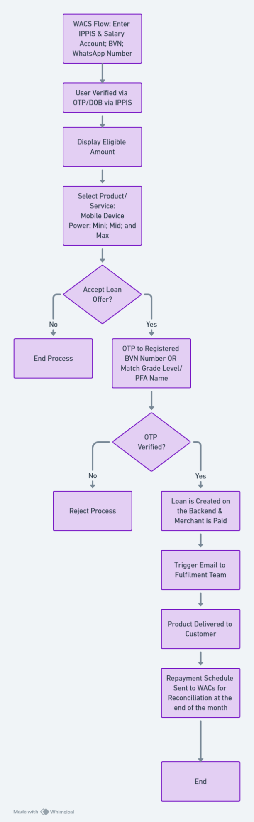  
**1. Fulfillment Process**

**1.1 End-to-End Workflow**

1. **Order Placement**
   * Customer selects product/service (financed via WACs).
   * Checkout captures delivery details and loan taken.
2. **Order Verification**
   * Auto-check for WACs financing approval (via API).
3. **Order Processing**
   * Approved merchant prepares order.
4. **Dispatch & Logistics**
   * Courier assignment with tracking ID generation.
   * Integration with logistics API for real-time status.
5. **Delivery Confirmation**
   * Customer receives OTP to confirm delivery.
   * System updates order as *Delivered* once OTP is validated.
6. **After-Sales Support**
   * 7–14 day return window (defective items only).
   * Dedicated support ticketing for warranty/returns.

**1.2 Dashboard for Transaction Tracking *(For Internal & Merchant Use)***

Key metrics:

* Orders in each stage (pending, processing, shipped, delivered).
* **Fulfillment time** (Order-to-dispatch & Dispatch-to-delivery).
* **Delivery confirmation rate** (% of OTP validations).
* **Customer feedback ratings** per product & merchant.
* SLA breach alerts (auto-escalations).

**1.3 Automated Notifications *(Email Push)***

* **Order Confirmation:** Email sent immediately after approval and payment to dedicated account
* **Delivery ETA Reminder:** 24 hours before expected delivery to Merchant/Fulfillment team
* **Delivery Confirmation Request:** OTP prompt upon arrival.

**1.4 Proposed Service Level Agreements (SLAs)**

* **Order Processing:** ≤ 24 hrs from approval.
* **Delivery:**
  + Small to Mid Size Items: ≤ 3 business days.
  + Larger Items: ≤ 5–7 business days.
* **After-Sales Response Time:** ≤ 24 hrs for first response, ≤ 5 business days for resolution.

**2.**

**3. Product Listing & Review Process**

**3.1 Pre-Listing Review**

1. Merchant submits product details via portal:
   * Title, description, specifications.
   * Price (financed).
   * Images (minimum quality standards).
   * Warranty terms.
2. Product listing checks:
   * Prohibited keywords/attributes.
   * Duplicate listing detection.
3. Manual review:
   * Compliance with product category guidelines.
   * Accuracy of description and price.

**3.2 Prohibited Items Enforcement**

* **Prohibited Product Database** (weapons, counterfeit goods, unlicensed electronics, etc.).

**3.4 Merchant Listing Visibility**

* Portal view showing:
  + Submission date.
  + Review status (Pending, Approved, Rejected).
  + Rejection reason + corrective action required.